Mohammad Ayaazuddin

Task-2

**QUERY**

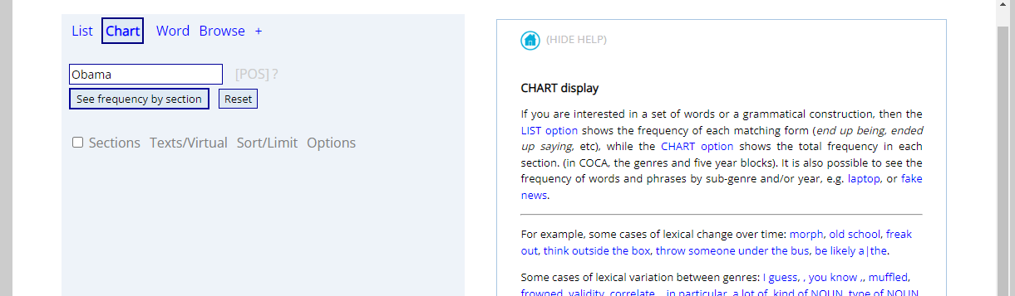

**CHART**

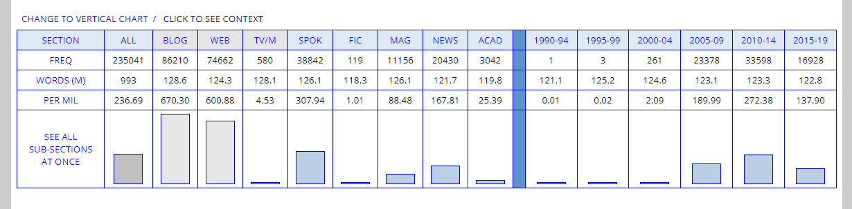

From the above Visualization, we can see that in the initial years from 1990 to 2004, use of Obama’s name in different forms was very less to overall less relevancy of Barack Obama, but after becoming a candidate and moreover later on the president of United States, there was a lot more discussion and talks about him.

**CONCODANCE**

